USRP Technical Report



Topic of Research:
Analysis Tools for Polar Stratospheric Cloud Studies
Using CALIPSO Data

John C. Wherry
Student’s Name Student’s Signature

Michael C. Pitts
Mentor’s Name Mentor’s Signature

Directorate:
Science Directorate

Branch:
Climate Science Branch

Date of Submission:
12/15/2008

Analysis Tools for Polar Stratospheric Cloud Studies
Using CALIPSO Data

Written by:
John C. Wherry, USRP Intern
Austin Peay State University

Technical report summarizing project completed during USRP program

Dr. Michael Pitts Mentor

Science Directorate
Climate Science Branch
NASA Science Mission Directorate

December 12th, 2008

Hampton, Virginia

Abstract

Studying the formation and evolution of polar stratospheric clouds (PSCs) is important to understanding different aspects of Earth’s global climate. Using CALIPSO (Cloud-Aerosol Lidar and Infrared Pathfinder Satellite Observation) data, we can better understand how these clouds affect the Earth’s climate. PSCs, which form over the polar regions during the winter at altitudes between about 15 to 30 km, play an important role in the formation of the ozone hole. The CALIPSO data is providing the first comprehensive set of PSC observations from space. To better understand how these clouds form and evolve with time, we combine the CALIPSO observations with different computer models. One, a microphysical cloud model, simulates how the clouds form and behave in the atmosphere. Another, an atmospheric trajectory model, simulates the transport of these clouds in the atmosphere. Analysis tools to help LaRC scientists explore the formation of these clouds and to simulate them with these models is highly needed. This project deals with the building of these analysis tools. LaRC scientists can now easily take large volumes of CALISPO data and compare them with findings from the models. This software makes the efficiency of analyzing PSC data increase tremendously and makes it easier for LaRC scientists to focus on more important aspects of PSC analysis.

- Introduction

One major problem with building a software system around an existing code base is the need for code refactoring. When it comes to refactoring an existing software system, many problems arise during the development of the new software system. Firstly, the computer scientist/software engineer has to have a thorough understanding of what the current system is doing. This makes for a steep learning curve where the programmer spends much time learning the system and not working on it. Secondly, the refactored code has to be of more benefit than it was before it was refactored. Being able to correctly do this is a challenge. Refactoring code consists of a few key concepts:

- System has been improved upon once the refactor is finished.
- New code is more modular and agile.
- The inner workings still produce the same output but in a cleaner, more efficient way.

By keeping these concepts in mind, software systems can be completely reworked in a fashion that produces a more reliable and efficient application. Refactoring the code in this project was an interesting feat. The Fortran models were written in different versions of Fortran: F77, F90, and F95. This made it difficult to debug the models once changes were made. The learning curve for the Fortran compiler and original model code was steep, this caused for a slow start. Just as mentioned above, there is a substantial part of refactoring that involves the learning of the new software system. In this project, the first couple of weeks were spent learning the inner workings of the Fortran code and complier in order to correctly refactor the system.

- Tools

IDL
The computer language that these analysis tools are written in is IDL. This language provides us with a great deal of flexibility in the work being done. In figure 1, you can see the plotting area in the center of the GUI (graphical user interface), it is very simple for IDL to calculate large volumes of data very quickly and visualize them. This is valuable in that it allows us to display images and results quickly without having to worry about all the in betweens that other languages have when dealing with displaying graphics. IDL creates a nice environment that is easy to learn and simple to use.

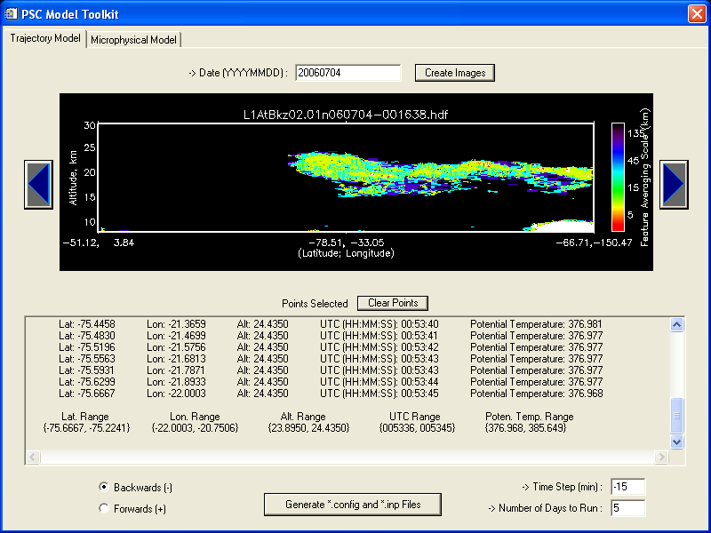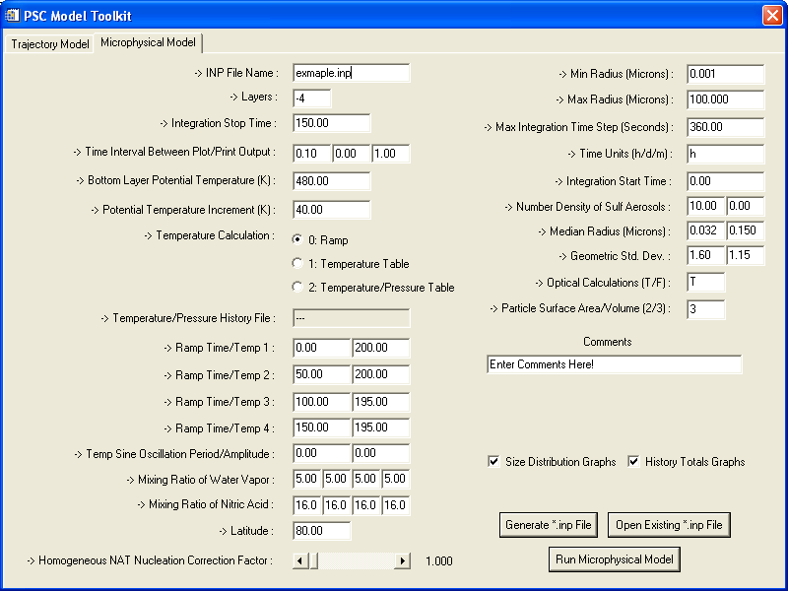
Fig. 1 Fig. 2
Trajectory Model GUI Microphysical Model GUI

Fortran
All of the models in this project are written in Fortran. The refactoring of the old Fortran to fit the new GUI IDL interface proved to be more difficult than anticipated. The Fortran code, being compiler specific, was hard to debug and refactor because it was more dependant on the compiler and not the language syntax itself. So Fortran and Fortran on a Compaq compiler had to be learned in order to refactor the code correctly.

- Results: Microphysical Model

The microphysical model that we use simulates how clouds form in the atmosphere. This model provides us with insight to the detailed processes of cloud formation mechanisms. If we can correctly simulate the formation of these clouds, we can have a better understanding of the system as a whole. Since PSCs play a large role in polar ozone depletion, understanding how they form is very important. The analysis tool that interacts with the microphysical model allows us to change the inputs to the model and run test cases very quickly. This gives us a lot of data to work with in a very short amount of time that would have taken much longer to accumulate before the tool was developed. Since the model helps us understand how PSCs form, being able to “tweak” the model inputs is a necessity. This allows us to easily change model input parameters to better simulate the observed data that CALIPSO provides. Process studies combining the microphysical model with CALIPSO data will ultimately lead to an improved understanding of the role of PSCs in ozone depletion.
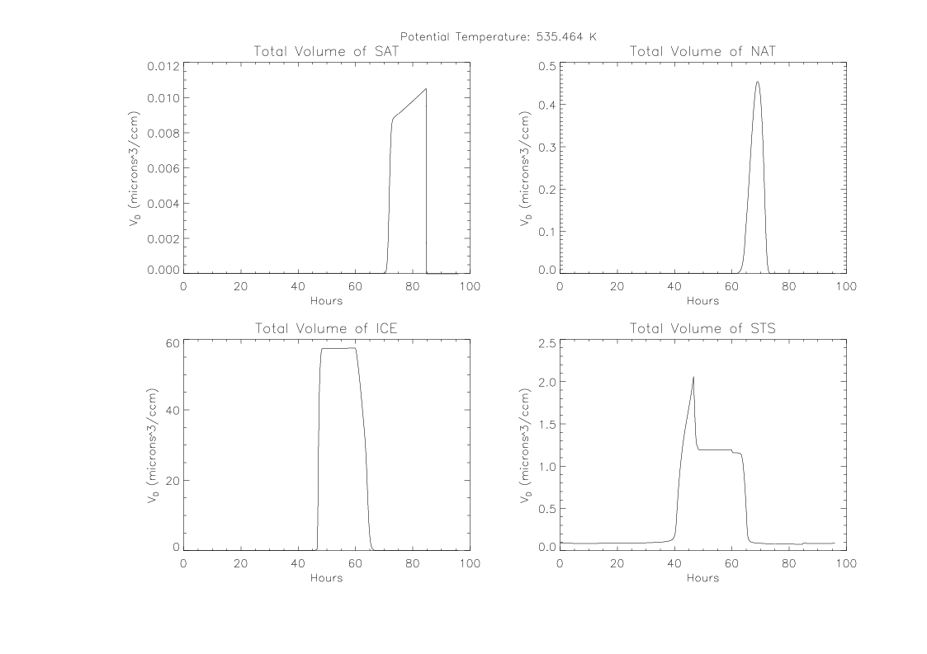
Fig. 3
Results from Microphysical Model

- Results: Trajectory Model

The trajectory model provides us with an easy way to track the movement (trajectory) of air parcels in Earth’s atmosphere. We select points from the CALIPSO data using the GUI tool (Fig. 1) and run those points through the trajectory model. This model can simulate both forward and backward trajectories, depending on the need. Fig. 5 shows an example air parcel trajectories for two PSCs observed by CALIPSO. The trajectory model is useful in PSC studies because it provides information on the source and time history of air parcels that ultimately become clouds. The GUI tool records temperature and other parameters at each time step along the trajectory path. The trajectory outputs can then be input into the microphysical model to simulate cloud formation along the trajectory. Process studies combining the CALIPSO data with both the trajectory and microphysical models will provide insight to PSC formation mechanisms. The analysis tool (Fig. 1) provides a highly effective interface for the trajectory model.

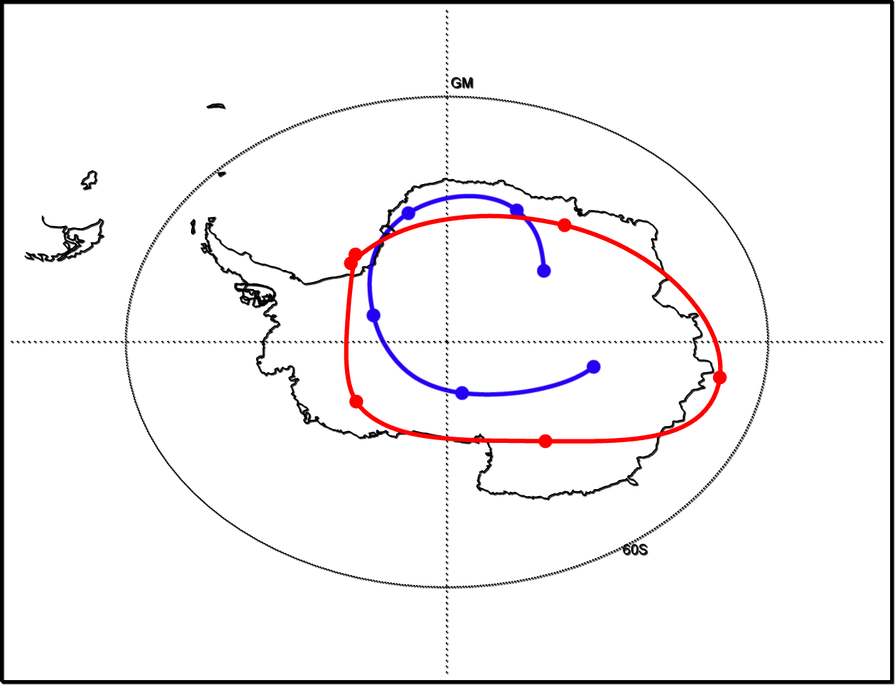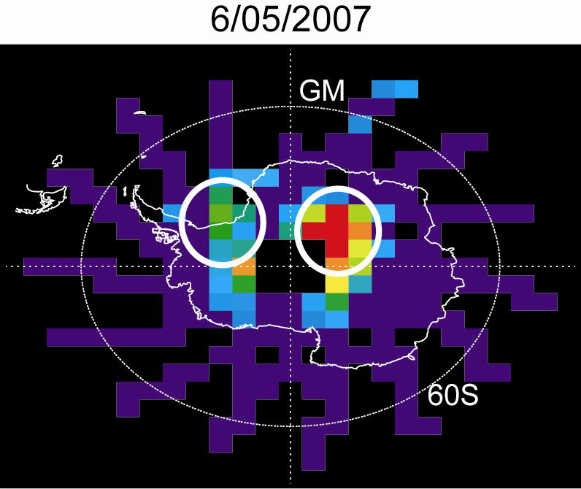
Fig. 4 Fig. 5

- Conclusion
This project has produced valuable analysis tools for the LaRC scientists. These tools provide an effective and efficient means to perform PSC process studies combining CALIPSO data with microphysical and trajectory models. By combing older systems and refactoring them into a newer GUI driven system, utilization of the models has been streamlined and greatly simplified. The LaRC scientists can now easily use these new analysis tools in their everyday analysis of PSC data without having the overhead of running cumbersome code and separate data plotting routines. The new software system is much more time efficient, allowing scientists more time to work on more important aspects of their research. Efficient software that simplifies the research process can be beneficial to the scientific community as a whole. New areas can be explored because researchers are no longer hindered by the limitations of the machine they are on or the software they are using. NASA’s own mission statement “To research, develop, verify, and transfer advanced aeronautics and space technologies “ can implemented at the very basic level here, starting with the development of new software to deal with the massive amount of research that NASA researchers undertake. Newer and better software systems provide almost limitless possibilities for research.

References

Compaq (1994). Compaq FORTRAN: A Language Reference Manual. Houston, Texas: Compaq Computer Corporation.

